Design Patterns Identification



Clara Sousa 58403

Design Pattern: Factory

Code Snippet:

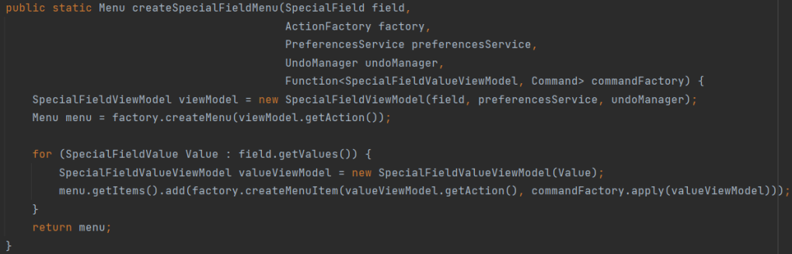

Location: src/main/java/org/jabref/gui/specialfields/SpecialFieldMenuItemFactory.java

Explanation: The purpose of a factory object is to work as a “virtual” constructor and have methods that create objects, instead of a typical constrcutor call, which is what the methods in this SpecialFieldMenuItemFactory class do, by creating different objects (e.g.: creating a menu from the created object “SpecialFieldViewModel”) that relate to their correspondent methods (respectively, the method “createSpecialFieldMenu”).

Design Pattern: Proxy

Code Snippet:

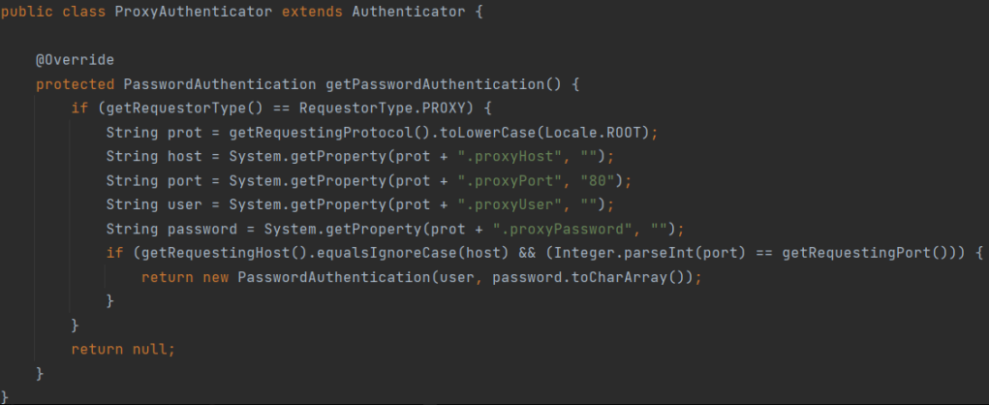

Location: src/main/java/org/jabref/logic/net/ProxyAuthenticator.java

Explanation: This class returns an object “PasswordAuthentication” if there is a match between the “System” object and a requestor; that is, the ProxyAuthenticator class works as an intermediate, which meets the definition of a proxy object in a Proxy design pattern.

Design Pattern: Composite

Code Snippet:

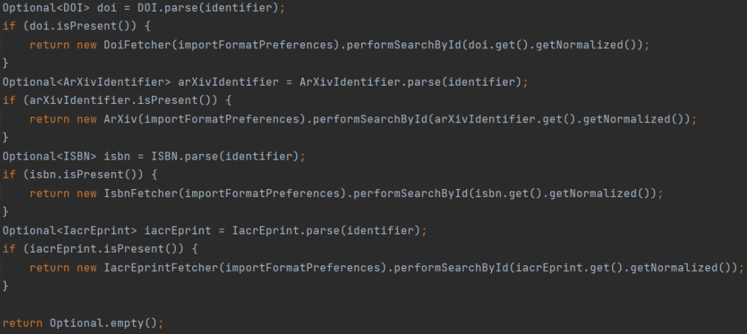

Location: src/main/java/org/jabref/logic/importer/CompositeIdFetcher.java

Explanation: In this class, new leaves are being created in different methods, regarding the first composite object. In this code snippet, for example, new objects are created in each “return new” line, according to the characteristics of the Optional<DOI> object.

